**Lab – 28: How to safely share a protected document by email?**

**Objective:** The objective of this lab is –

* To safely share a protected document by email.

In this lab, we are going to share a protected document safely by email. You can simply locate a Word document or Excel spreadsheet that you have already created and will send to a partner or co-worker.

**Prerequisite:** EMS Enterprise Mobility + Security E5.

**Steps:**

1. In File Explorer, right-click your document and select **Classify and protect**. The Classify and protect - Azure Information Protection dialog box opens. So, the confidential data that requires protection which allows all employees full permissions. Data owners can track and revoke content.

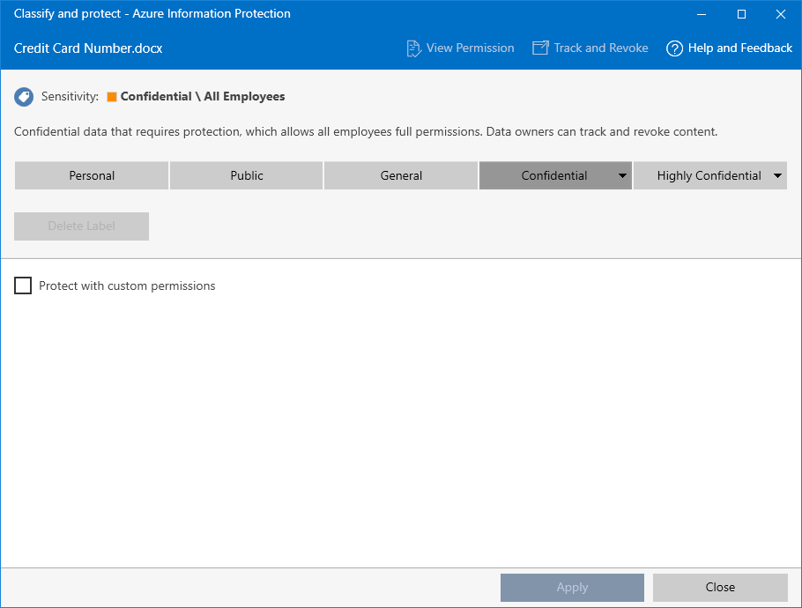

1. Select **Protect with custom permissions**, which displays additional options.
2. For **Select permissions**, options available are – Viewer – View only; Reviewer – View, edit; Co-Author – View, Edit, Copy, Print; Co-Owner – All Permissions; and only for me. So, keep the default of **Viewer – View Only**. With this setting, our recipients will be able to view the document but not edit or print it.

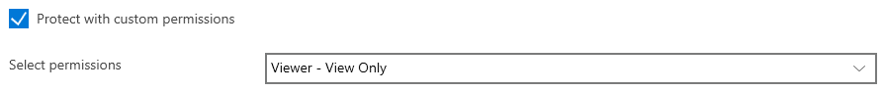

1. For **Select users**, type one or more business email addresses, as you would do when you send a document to someone that your organization does business with. To specify more than one address, you use a semicolon (;) or press Enter. Make sure that you specify a business email address, such as **janetm@contoso.com** or **p.dover@fabrikam.com** because currently, Azure Information Protection doesn’t support personal email addresses for this scenario. Alternatively, click the **Select users, groups, or organization icon** to select a co-worker's email address:

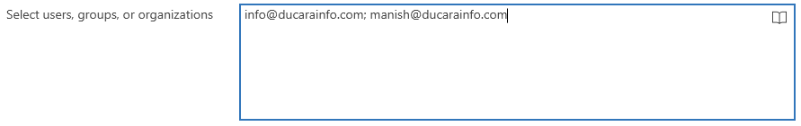

1. Click **Apply** and wait for the **Work finished** message to see the results. Then click **Close**.
2. Back in File Explorer, right-click your file again, and this time, select **Send to** > **Mail recipient**. This action attaches your document to an email message with some default text that we will change.
3. Before we change the default text, enter the email addresses that you specified earlier into the **To** box.
4. Optionally, type your choice of subject in the **Subject** box, for example: **I am sharing a protected document**.
5. Modify the default message description so that it's suitable for your recipients. However, add the text: **I've protected this file with Microsoft Azure Information Protection**.

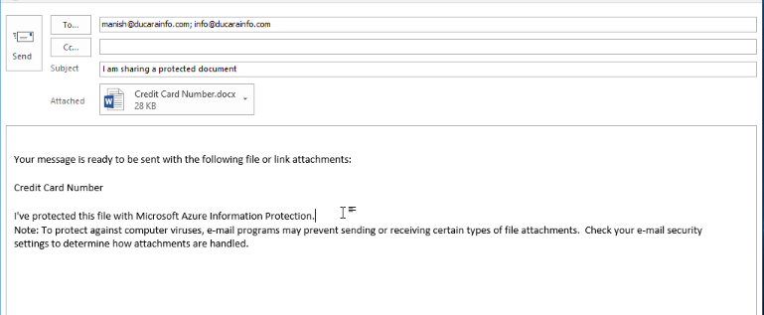

1. Click **Send**.
2. Now you’ve sent your protected document, you’re ready to ask your recipients to wait for it to arrive and then open it.
3. So, in this way you can safely share a protected document by email.